Simultaneously press ‘windows key’ + ‘r’ to bring up the run dialog box. Enter ‘cmd’ and press enter to bring up the command line.

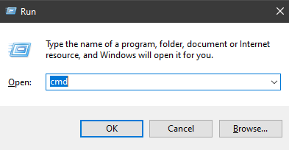

If you haven’t already, install pyinstaller through the following command.

‘pip install pyinstaller’

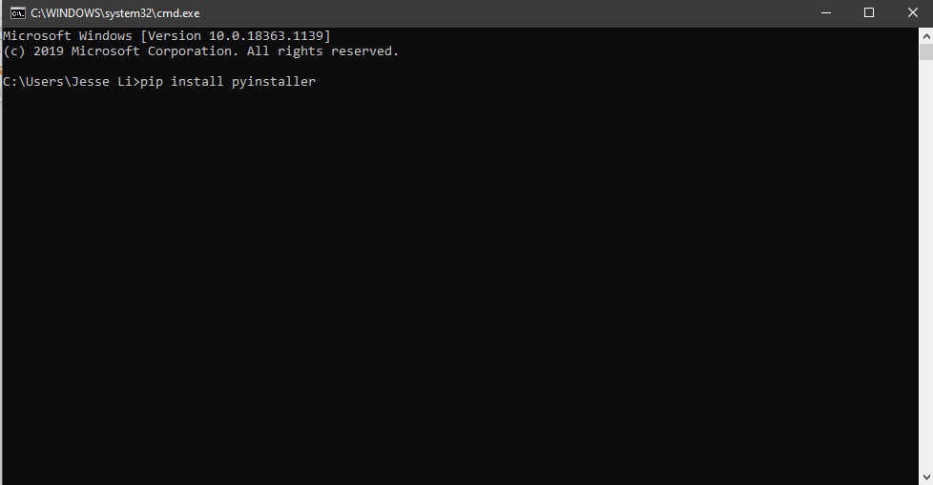

Follow the prompt and enter ‘y’ when it asks you to.

After it is installed, you can proceed to follow the following set of instructions to convert any .py file into an .exe. All the libraries imported, whether from the core libraries in python, or external sources (such as those written by yourself or downloaded from online) will automatically be added as well.

First navigate to the working directory. If using absolute path, wrap it in “” double quotation marks in case of spaces as in my case.

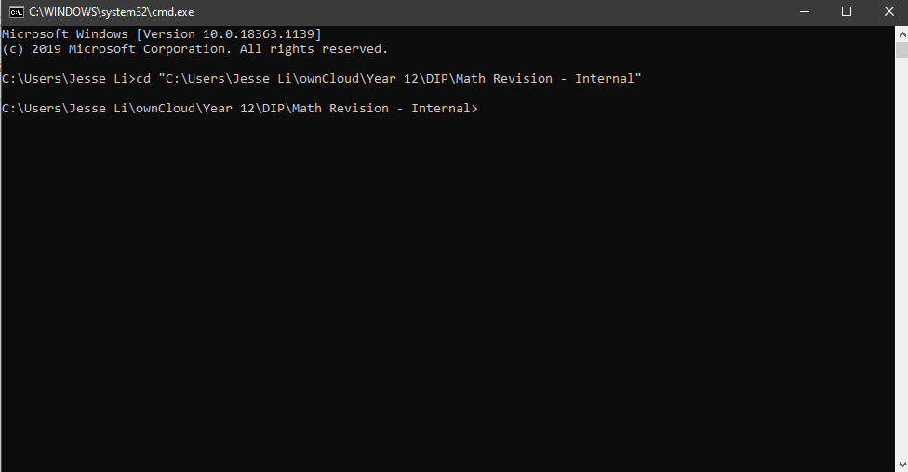

Next run the following command to run pyinstaller

‘pyinstaller –onefile [INSERT FILE NAME HERE WITH EXTENSION]’

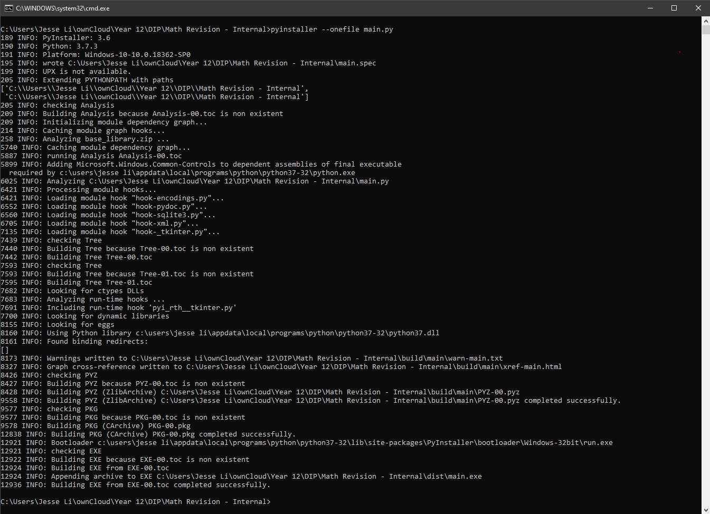

You will notice two new folders ‘build’ and ‘dist’, as well as a spec file. You can ignore the build and spec files as they are for the pyinstaller. The one .exe file will be in the ‘dist’ folder which stands for distribution.

You can omit the –onefile parameter, which will install the libraries and such separately.